

**Project Report On**

**National Park**

**Table Of Contents**

1. **Acknowledgments**
2. **Information About Developers**
3. **Introduction About Project**
4. **Analysis**
5. **Screen Shots**
6. **Final Statement**

**Acknowledgments**

The combine Study on this project is an honor for our group members.

We were eager to make such a dynamic and interesting project, which may provide us with a huge amount of practical knowledge and will help us use our skills efficiently.

Our heartiest appreciation and gratitude towards our teachers, whose help, dedication and encouragement has helped our team members to successfully, achieve our goals.

We are grateful to Aptech for providing us necessary facilities and the support which we needed and also for providing us the opportunity to practically implement what we have learned, which will help, help us in future.

**Information About Developers**

|  |  |
| --- | --- |
| **Student1521663** | **MUHAMMAD ANAS KHAN LODHI** |
| **Student1511299** | **MUHAMMAD WAQAS** |
| **Student1521654** | **HAMZA JAWAID** |
| **Student1526007** | **MUHAMMAD AHSAN** |

**Introduction About Project**

The National Park website is a captivating online platform developed to showcase the information about the national parks and birds and animals there.

This project seamlessly combines HTML, CSS, JavaScript, and Bootstrap to create an immersive and user-friendly website that caters to both aesthetic appeal and functionality.

By leveraging modern web technologies, the website provides a visually stunning experience while ensuring seamless navigation and easy access to information.

**Analysis Purpose**

The analysis of national parks serves a multifaceted purpose, encompassing ecological assessment to evaluate biodiversity and ecosystem health, visitor use analysis for enhancing recreational services, resource management to conserve natural resources, cultural heritage preservation, economic impact assessment to gauge benefits on local communities, policy development for park protection and sustainability, and education and outreach initiatives aimed at raising public awareness about conservation.

Through comprehensive analysis, national parks can better understand their ecological, social, and economic dynamics, enabling informed decision-making to ensure the long-term preservation and enjoyment of these treasured landscapes for future generations.

**Snapshots**

**Home page**

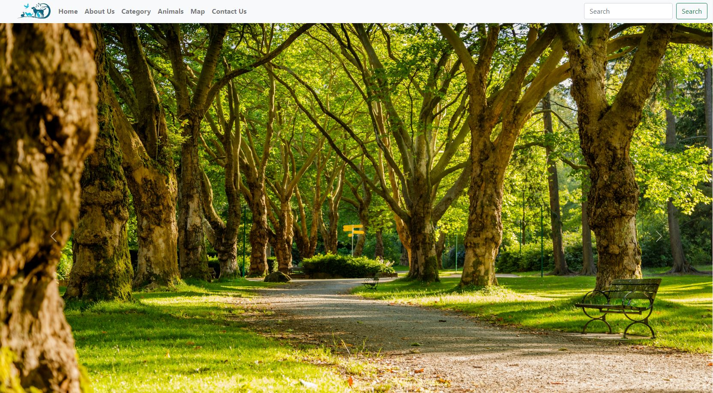

**About Us**

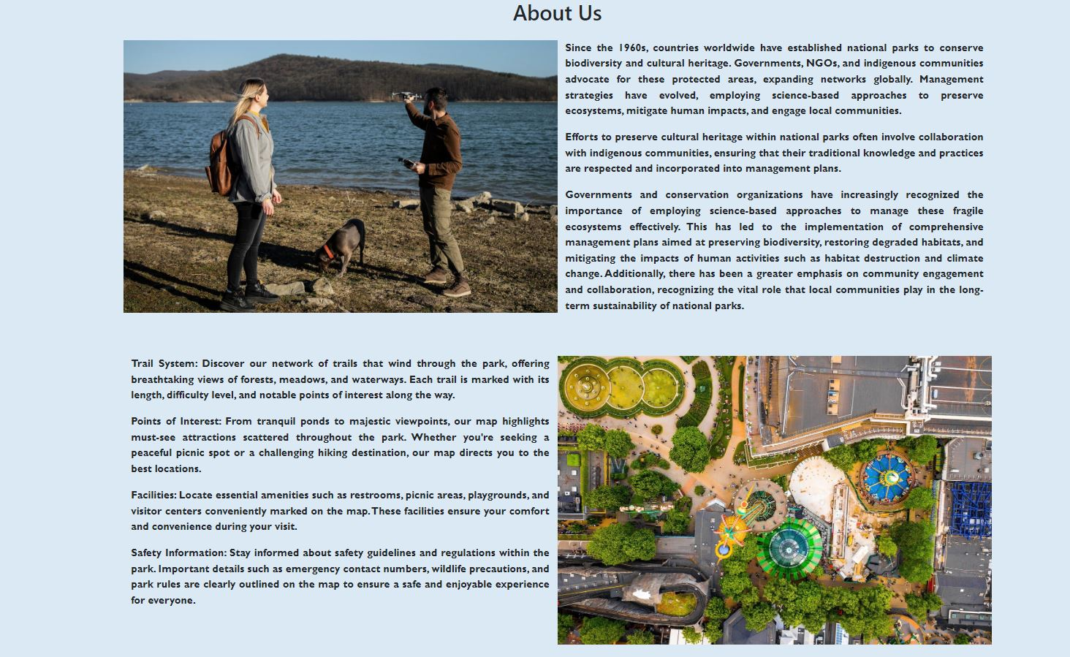

**Category**

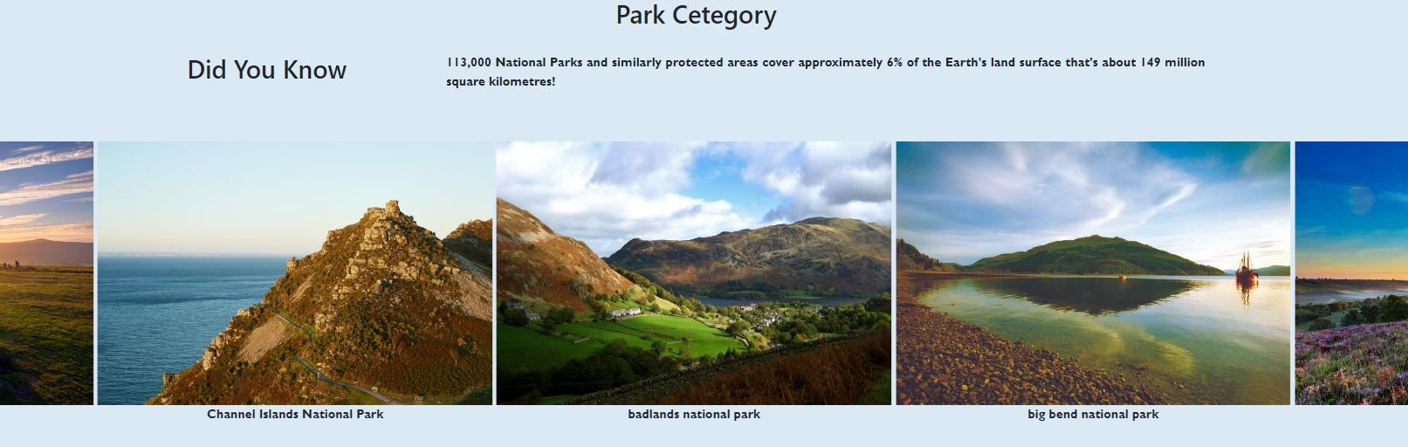

**Animals** 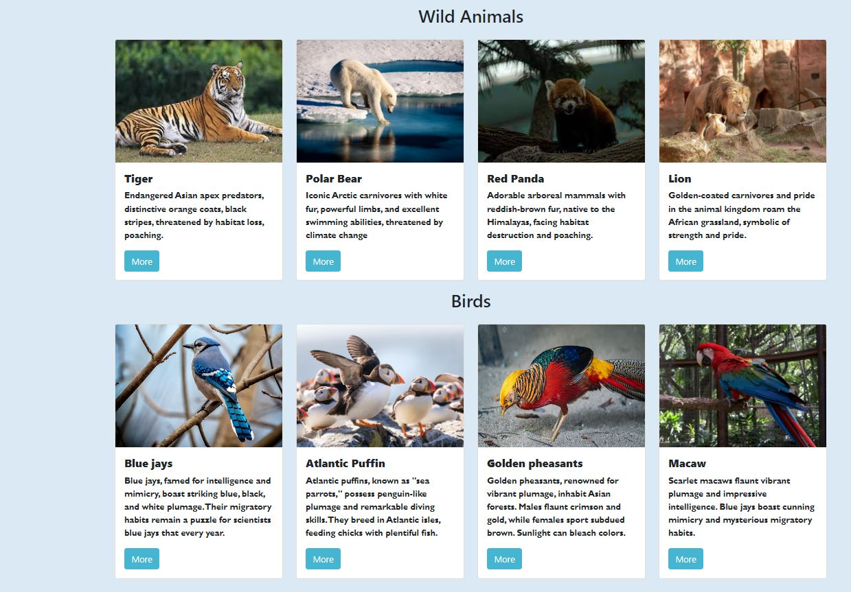

**Our site location**

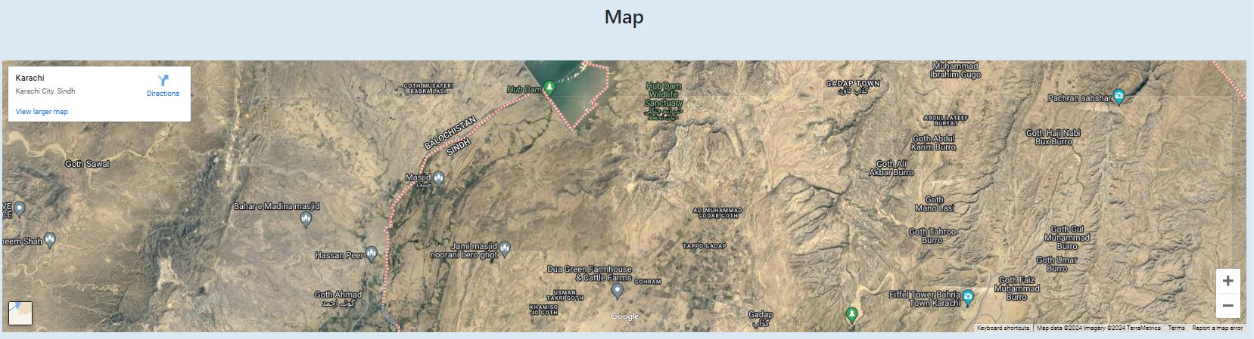

**Contact us page**

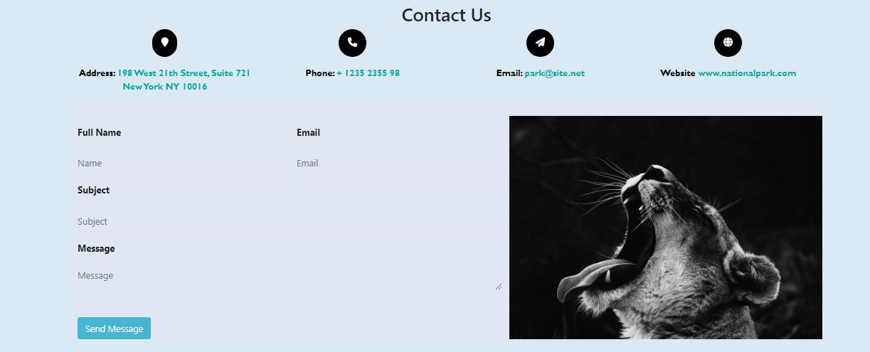

**Final Statement**

This E Project was created with Firm Determination. We students did lot of hard work to complete this project on time.

We did our best to made this project perfect, work full, help full, easy to use and Qualified as much as possible.

We Kept the future technologies and usage in our mind while making this project.

We hope That APTECH will like our project and will appreciate our hard work and Firm Determination.

THANK YOU!